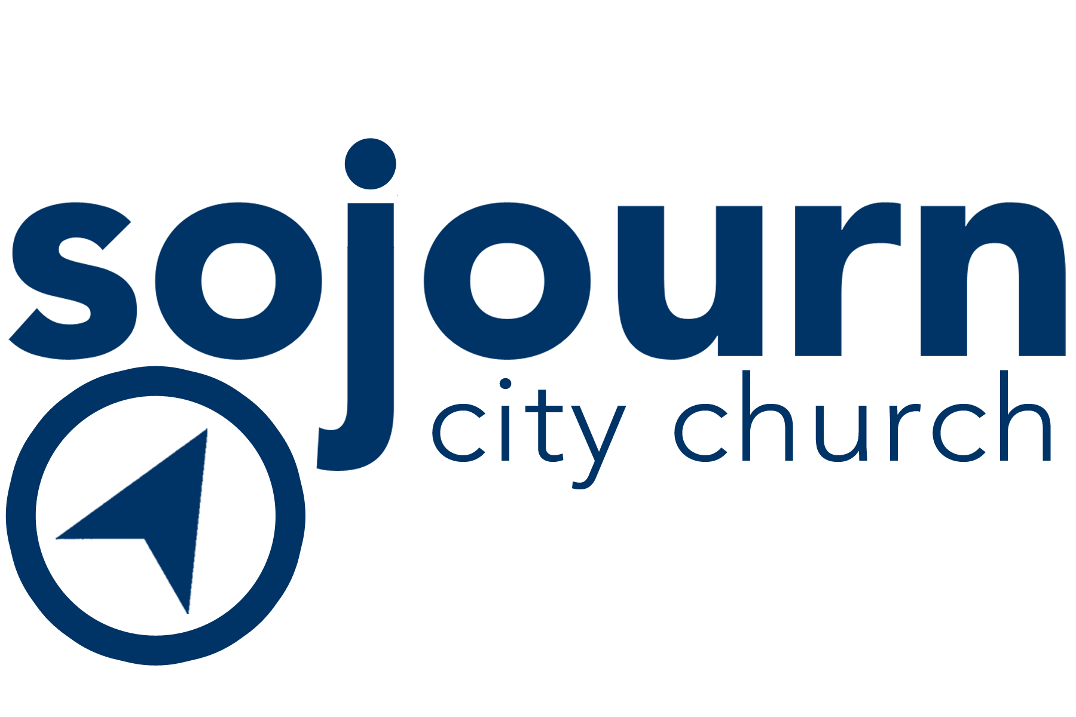

A-TEAM
“Each one should use whatever gift he has received to serve others, faithfully administering God’s grace in its various forms.” 1 Peter 4:10
TEAM VISION
To administer excellence within the logistics of Sojourn City Church, so that our guests can reach their full potential in Jesus Christ.
TEAM RESPONSIBILITIES
We love God.
- Prepare in prayer. Pray for God’s heart for people each and every time you serve. Ask God how you can put someone else at ease, for the Lord to use you today, and how you can most authentically demonstrate His love. Pray for Heaven’s heart and Heaven’s hands.
- “Worship One, Serve One” is our motto. We encourage everyone to offer worship to the Lord, with song and service; in hearing the Word and demonstrating it.

We Love People.

- Dream Team Central has snacks, water, and check-in opportunities for you. It is also a great way to connect with other Dream Team members!
We Pursue Excellence.
- Serve when scheduled. You will be scheduled to serve twice a month based on the service time and rotation schedule you select (either 1st & 3rd Sunday or 2nd & 4th Sunday rotation options). If you have a conflict with your regularly-scheduled service time, notify your Team Leader. Communication is crucial for effectively serving our guests with excellence and building team community. Scheduling will occur through a computerized program called Planning Center. You will receive a text and email to schedule and remind you of the services that you are scheduled. You must respond to the scheduling requests. This process will be explained during the Team Huddles.

We Choose Joy.
- Serve with heart, commitment, and excellence. We want you serving in your gifts and passions; in ministry that is an overflow of love and enjoyable to you. If this ministry is not a fit, if you would like to investigate a new ministry team, or if you need a break from serving for a season, do not hesitate to let your Team Leader know. This is why they are here -- to walk through life with you!

TEAM ROLE
- Your role at Sojourn City Church serves the overall vision by making sure that our systems are in place and are effectively working. The A-Team is a group of like-minded men and women who find much value in details, numbers, and spreadsheets. This team understands that one of the best ways to pastor people is to create systems that don't forget them. This is accomplished through:
  - Follow-up with new Sojourners, getting them the information necessary to get them started in Growth Track
  - Upkeep of the database with Sojourners current information and progress in Growth Track.

- Complete your assigned task— as it may vary from week to week.

- Email will be your lifeline of communication. Please check your account weekly as to task, to-do’s, and scheduling.

- Partner with the Body of Christ by inviting and serving people while authentically representing Jesus. You have been entrusted by our church to serve their family members, friends, and co-workers who may not yet know Jesus. Your role in the Kingdom is essential.

TEAM RESULTS
Growth Track guests are loved, cared for, and communicated with effectively and in a timely manner.

How to join the Team:
- Complete Growth Track steps 1-4 and meet one-on-one with ministry leader.
- Complete the Leadership Application and Honor Code.

